

Space, Range and Merchandising Programme
Ranging Controls

Store Clustering
(Pre-Ranging Phase 2)
Business Process Design

Author: S. Buchanan

Version: 1.1 – Draft

Document Sign-off

For sign-off:
Danielle Coe | Range Programme 3 Project Manager
Adam Harrison | IT SRM Project Manager
Jim Clifton | SRM Planning and Change Manager
John Wootton | Range Programme 3 Project Manager

For information:
Steve Player | GT&A
Mark Croft | Operations Manager

Document Control

Date | Author | Change Description | Version
31 Jan 06 | Sue Buchanan | Created document | 0.1
9 Feb 06 | Sue Buchanan | Adam’s comments – restructure and name change | 0.2
17 Feb 06 | Sue Buchanan | Comments from Lucy – clarification of scheduled and non-scheduled processes | 0.3
23 Feb 06 | Sue Buchanan | Workshop comments | 0.4
10 Mar 06 | Sue Buchanan | Pre-issue feedback from Danielle | 0.5
13 Mar 06 | Sue Buchanan | Pre-issue feedback from Adam | 0.6
13 Mar 06 | Sue Buchanan | Issued draft for review | 1.0
27 Apr 06 | Sue Buchanan | Comments on first draft from Meryl, Danielle, Nick ,Bob, Adam | 1.1

Document Purpose

This document has the following purpose:
- To facilitate the business process sign-off with the business
- To enable progressions to the system design.

Sign-off for this document is required to ensure that the solution design and final configuration will support the proposed processes and fulfil the business requirements.

Contents
1 INTRODUCTION 5
1.1 Management Summary 5
1.2 Ranging Controls – Programme Overview 6
1.3 Store Clustering - Project Overview 8
1.3.1 Objectives 8
1.3.2 Deliverables 9
1.3.3 Benefits 10
1.3.4 Assumptions 10
1.3.5 Constraints 11
1.3.6 In Scope 11
1.3.7 Out of scope 11
2 “AS IS” BUSINESS PROCESS 12
2.1 Introduction 12
2.1.1 Pre-Ranging overview 12
2.1.2 Terminology 12
2.1.3 Defining the “As Is” 14
2.2 Process Overview 15
2.3 Current Processes 16
2.3.1 Processes triggered by a Scheduled Event 16
2.3.2 Processes triggered by UKBE 19
2.3.3 Processes triggered by exceptional circumstances 23
2.4 Current Process Issues 26
2.5 Current System and Architecture 28
2.5.1 Current System 28
2.5.2 Current architecture 28
3 “TO BE” BUSINESS PROCESS 29
3.1 Introduction 29
3.2 Process Overview 29
3.3 To-Be Processes 31
Processes triggered by a Scheduled Event 31
3.3.2 Processes triggered by UKBE 32
3.3.3 Processes triggered by exceptional circumstances 32
3.4 To-Be System Architecture 33
4 REQUIREMENTS 34
4.1 Business Process Requirements 34
4.1.1 Follows Ranging Controls end-to-end business process 34
4.1.2 Integrated into all parts of the business 34
4.1.3 Enhanced functionality to manage the process 34
4.1.4 Data availability and reporting 34
4.2 System Requirements 35
4.2.1 Maintain the functionality and integration of Pre-Ranging1 35
4.2.2 Interface must be intuitive and easy to use 35
4.2.3 Sufficient flexibility to change data at any time 35
4.2.4 System integration with Ranging Controls applications 35
4.2.5 Improved functionality for creating clusters 36
4.3 Other Requirements 36
4.3.1 Process and design moving towards required IT Strategy 36
4.3.2 Adequate level of documentation and training 36
5 SOLUTION ISSUES & RISKS 37
5.1 Risks 37
5.2 Issues 37
6 APPENDICES 38
6.1 Appendix A – Scheduled Event flow, pre-Phase A 38
6.2 Appendix B – Application Overview (As-Is) 39
6.3 Appendix C - Pre-Ranging 1 bugs and change control issues 41

INTRODUCTION

Management Summary
The systems and processes that deliver the current Space, Range and Merchandising solutions are struggling to cope with the demands of the expanding business. As the business continues to grow, a solution is needed that supports:
- More flexible and varied range requirements
- Higher level of planning sophistication
- Increased number of stores and formats.

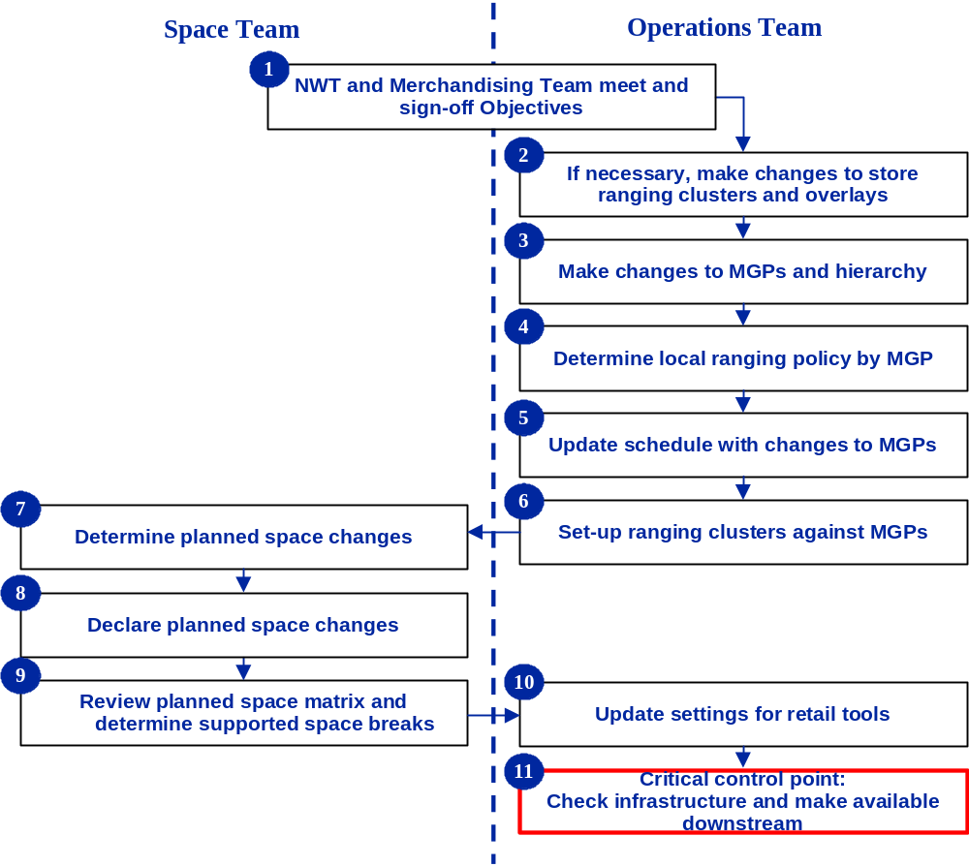
An end-to-end business process for Space, Range and Merchandising: Ranging Controls has been identified. Based on this process, an infrastructure is being developed that continues to support current activities whilst removing current constraints and supporting future growth requirements.

Space, Range and Merchandising: Ranging Controls
End-to-end Business Process

Note: the terminology for this project is defined in section 2.1.2 Terminology.
The Store Clustering project will deliver functionality to support the following steps in the Space, Range and Merchandising: Ranging Controls end-to-end business process:
- Step 2: If necessary, make changes to the store ranging attributes and overlays
- Step 6: Set-up ranging attributes against Merchandising Groups (MGPs)

Pre-Ranging 1 has already delivered the ability to:
- Define ranging attributes against stores, i.e. group stores by attribute type (e.g. country, format and affluence) at the merchandising group level, and specify stores to receive overlays
- Specify ranging attributes against merchandising groups, i.e. define which store clusters and overlays are used for each merchandising group

Store Clustering, the second phase of Pre-Ranging, will build on the existing functionality to deliver the following process and system enhancements:

Business Process:
- Integration into the Ranging Controls end-to-end business process
- Expanding the use to cover all types of change including the potential for non-ranging clusters
- Greater control for managing changes
- Enabling previously unavailable processes, i.e. deleting attributes types

System functionality:
- Improved usability
- Intuitive and easy-to-use screen designs
- Flexibility to allow data to be changed at any point in the critical process
- Improved functionality for creating clusters
- Integration with Ranging Controls applications
- Continuing to deliver the current levels of functionality and integration
- Improved data visibility and reporting functionality

Other functionality:
- Design that is moving towards the required IT strategy
- Required levels of documentation and training

Ranging Controls – Programme Overview
Space, Range and Merchandising: Ranging Controls is designed to support the core business processes (see Space, Range and Merchandising: Ranging Controls, End-to-end Business Process). To enable maximum interactivity, Space Range and Merchandising, Ranging Controls has been designed to operate as a single application made up of multiple components, all sharing the same data. This means that the user will logon to one application, and from the same top-level menu screen, be able to select whichever functionality they require, e.g. schedule, planned space, store clustering, etc.

The following diagram shows the high-level design of Ranging Controls, and the relationships that will support the core business process.
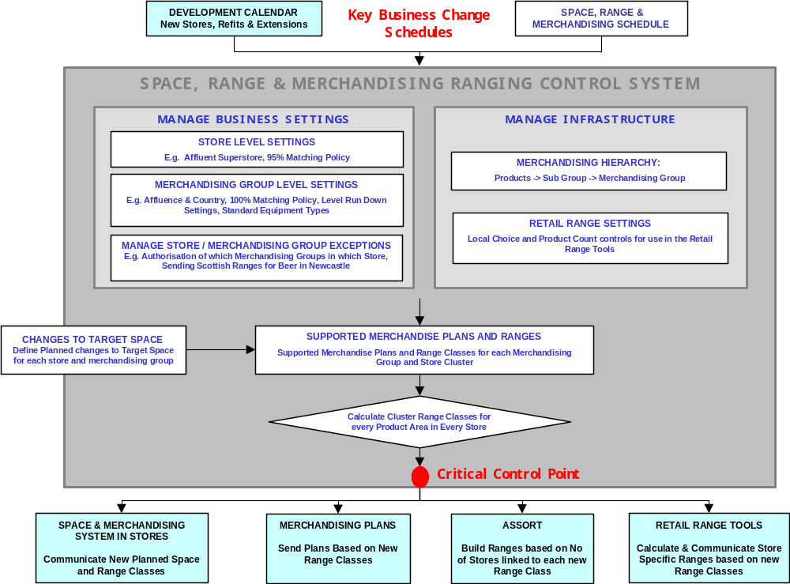
Space, Range and Merchandising: Ranging Controls Components

Within the business objectives described in section 1.1, the Space, Range and Merchandising, Ranging Controls project will deliver a design that:

- Supports the new Ranging System
- Provides applications that are easy to use and maintain
- Provides functionality that allows changes to become effective at a future date
- Provides all maintenance settings and controls in one central location
- Starts to migrate the Ranging Controls legacy IT systems to a new technology

The Space, Range and Merchandising: Ranging Controls infrastructure will be delivered in four phases. Currently, the three phases are defined as follows:

Ranging Controls Phase A: Ranging Controls Framework
Deliverable | Description
Ranging Controls | User interface with common menus, security, etc for all Ranging Controls applications.
Space, Range and Merchandising Schedule | Supports the set up and maintenance of scheduled events. Also the control point for sending approved data to other systems.
Merchandising Group Maintenance | Support the central maintenance of all merchandising group data.

Ranging Controls Phase B: Store Clustering and Space Changes
Deliverable | Description
Planned Space and Authorisation | Supports the process to upload and make visible multiple future-dated planned space targets for any merchandising group and store combination.
Store Clustering | Supports the set up and maintenance of characteristics used in ranging merchandising groups. Associates these characteristics to groups of stores (“clusters”) which are then used in ranging activities

Ranging Controls Phase C: Managing Supported Ranges and Equipment
Deliverable | Description
Supported Merchandising Plans and Ranges Matrix | Facilitates the creation, maintenance and visibility of current and future relationships between range class and space.
Equipment Matrix | Master list of all supported equipment types. Controls and settings for identifying equipment.

Ranging Controls Phase D: Critical Control Point Summary and Equipment
Deliverable | Description
Cluster Range Classes | Calculates the range class for each store by merchandising group and provides reporting on the impact of any changes to the Infrastructure
Impact Reporting | A suite of reporting to support the business processes.

Store Clustering - Project Overview

Objectives
To integrate Pre-Ranging 1 into Space, Range and Merchandising: Ranging Controls:
- Ensure the same look and feel as other Ranging Control applications: screen design, navigation, menu structures
- Following guidelines in Standards document and the BSD for Ranging Controls (Flightdeck)

To integrate and align to the end-to-end business process:
- Standard use of locking/unlocking events

To rationalise the technology design in line with the strategic technical design including wherever possible, rationalising and minimising feeds to and from legacy systems.

To make attributes available for tasks other than ranging within the Space Range and Merchandising programme.

Deliverables
Store Clustering will deliver the following improvements.

Business Process improvements:

Integration into Ranging Controls end-to-end business process:
Screen designs that reflect end-to-end business processes
Full functionality that removes the constraints of merchandising group authorisation. .
Processes that can be used for all parts of the business:
Processes that fit UKBE, scheduled events, store-led changes, special projects and ad-hoc requests
Enhanced functionality to manage the process:
User-access levels to control access to critical functionality such as deletion
System validation and confirmation messages
Operational reporting for users updating the system
Data visibility and reporting functionality:
On-screen and hard copy reporting

System functionality improvements:

Intuitive and easy-to-use screen designs:
Menus structured to follow business process flow
Look and feel following Ranging Controls standards
Logical screen design that makes functionality understandable and easy to use
Removal of redundant functionality within Pre-Ranging 1 e.g. Event locking and unlocking
The flexibility to allow data to be changed at any time:
Enhance user-access levels and business rules within the standards defined for Ranging Controls, to ensure restricted access to business critical operations.
Future-dated changes to be amended or deleted in line with business processes at any point in the critical path
Integration with Ranging Controls applications:
Integration with all Ranging Controls Applications, including those to be delivered as part of Phase A and Phase B, for example, integration with the Space Range and Merchandising Schedule and Planned Space and Authorisation
Maintaining the current functionality and integration of Pre-Ranging:
Changes will build on the current functionality e.g. multiple future-dated changes, attribute management, linking attributes to stores/merchandising groups, cluster definition
Retention of links to other systems (e.g. CRST, Event Schedule)

Other improvements:

Process and design moving towards required IT strategy
Working towards minimising the dependency on legacy systems
Continue to meet requirements of the Space Range and Merchandising Programme for Assort, Ranges In Progress (RIP) and Pro-Space

Documentation and training
Updated Pre-Ranging documentation and training materials to include a description of the changes made for Store Clustering
Additional documentation and training materials where required.

Benefits
Delivering Store Clustering project presents the following business benefits:

Introducing the concept of clustering for non-ranging events

Improving existing functionality and usability

Greater flexibility in building ranges

Improved accuracy of store ranges

Reduced need for expert system-knowledge

Assumptions
The following assumptions are made:
- Single digit region code is retained for downstream systems e.g. Pro Space and VMCS
- Pre-Ranging is launched, implemented and stable before integration testing
- Ranging Controls Phase A is launched, implemented and stable before integration testing
- All Pre-Ranging bug fixes and agreed business changes are complete

Constraints
In achieving the objectives of Store Clustering, it is necessary to ensure that:
- the core functionality of Pre-ranging (managing ranging attributes, linking attributes to stores and defining clusters) is not compromised.
- the system is sufficiently flexible that any known future opportunities to expand the use of Store Clustering across the business does not compromise the core functionality, i.e. the ability to define ranging attributes against stores, specify ranging attributes against merchandising groups and create store clusters must continue to be available.

In Scope

Countries | All UK and Northern Ireland stores
Stores | All formats that follow standard business process, including Home Plus
Merchandising Groups | Food and non-food (saleable and orderable merchandising groups)
Systems | Maintain integrity of current Pre-Ranging 1 system data feeds.  Removing functionality from legacy systems where it is replaced or made redundant by Store Clustering functionality.  Updating existing system to reflect the revised business process  Feeding data into the Data Warehouse
Processes | Updating business processes including documentation and training materials.

Out of scope

Countries | ROI and International
Stores | Express, PFS, Pharmacy, Dotcom
Merchandising Groups | Express merchandising groups  Passing information for Non-food to Assort
Systems | Pre-Ranging 1 bug fixes and agreed Phase 1 business changes and change control  Data Warehouse reporting and Management Information

“AS IS” BUSINESS PROCESS

Introduction

Pre-Ranging overview
The Pre-Ranging application defines the store clustering (sets of stores with selected attributes in common) that is used for ranging activities. It is the first step in an end-to-end process that defines product ranges:
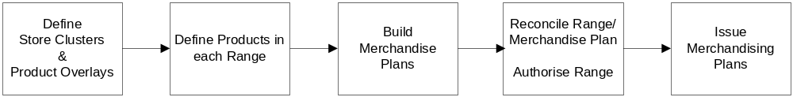

Steps in the Ranging Process

Applications in the Ranging Process

To define the store clustering used in the ranging activities, the Pre-Ranging application enables the:

- Definition of ranging attributes (e.g. store format, country and affluence) against store/merchandising group combinations:
- Group stores by country, format and other ranging criteria at the merchandising group level
- Specify stores to receive overlays
- Specification of ranging attributes against merchandising groups:
- Define which store clusters will be used for which merchandising group
- Define which overlays will be used for which merchandising groups

A brief overview of the Pre-Ranging application is given in Appendix B.

Terminology
Attribute Type | High-level characteristics used to distinguish different types of stores. The current Attribute Types are:  - Format  - Country
Attribute Value | Values for the Attribute Types that are used to distinguish between different stores.  The current Attribute Values include:  - Format: Classic Metro, Metro, Superstore, Extra,  - Country: England, Scotland, Wales, Northern Ireland  Every store must be assigned one value only for each Attribute Type.
Cluster | A group of stores that have selected attribute values in common. When used for ranging, a store cluster will be deemed to display similar trends for retailing a particular merchandising group and will therefore be ranged in the same way.  For example:  - Extras in upmarket areas of Scotland  - Metros in price sensitive areas of Wales
Overlay | Mechanism used to replace part of a range of products with another range of products more suitable for the store. Overlays appear in store-specific Merchandising Plans (SSPOGS), not the Master Merchandising Plan.  Overlays can be used to tailor one range of products (e.g. a Sausage overlay may replace sausages available nationally with sausages made locally) or the products in several merchandising groups (e.g. a Cornish overlay will replace products in merchandising groups such as dairy, ice-cream and cheese).  Overlays can be applied to a single store, or a group of stores and at Merchandising Group level.  Other examples:  - A Seasonal overlay used to replace product ranges for many merchandising groups, for stores in popular sea-side locations, e.g. Ilfracombe; Blackpool; Brighton  - A Kosher overlay used to replace product ranges for specific merchandising groups, for stores in areas of high Jewish population such as Finchley.
Attribute Exception | Mechanism used to override a store’s attribute value with a value that can be used for ranging. Exceptions are associated at the Merchandising Group level.  For example:  - A store defined as an Extra may have physical space that is more like a Superstore than an Extra. This would require the store to receive the Superstore product range for some Merchandising Groups.
Region Code | Single character code of the value 0-9 or A-Z, used to define the cluster that the store is in for a particular merchandising group.  Region Code has a 1-to-1 relationship with clusters per merchandising group.  The same region code may be used differently across merchandising groups.  For example, for the same cluster (e.g. Scottish, Upmarket, Extra) merchandising group B1B may have the region code S, and merchandising group B1E the region code T.

“As Is” Process Overview

Defining the “As Is”
The Pre-Ranging application will be launched initially as part of the Assort project rollout. Ranging Controls Phase A will be delivered after the initial launch (see section 1.2 Ranging Controls – Project Overview) and will impact some of the business processes supported by Pre-Ranging.

This document assumes the “As Is” processes to be post implementation of both Pre-Ranging and Ranging Controls Phase A.

The process flow for a Scheduled Event prior to implementation of Ranging Controls Phase A is given in Appendix A. Gaps in the diagram are used to illustrate where additional steps have been included for the process post-implementation of Ranging Controls Phase A.

Introduction
After the initial set-up of the system, the Pre-Ranging application becomes essentially a maintenance tool, to support:

- Scheduled merchandising events
For example, introduction of a new merchandising group that involves defining clusters for the merchandising group and updating existing merchandising plans
- Work driven by UK Business Expansion (UKBE)
For example, opening a new store or an extension to an existing store, refitting the interior of an existing store.

In addition to support these two types of process, occasional exceptional circumstances may also require Pre-Ranging changes. For example, the introduction of a new store format (e.g. a Tesco Hypermarket), or the decision to cluster stores on an additional attribute value (e.g. “Busyness”).

The following Pre-Ranging tasks must be performed only as part of a Scheduled Event, because they will impact the product ranges available in stores and change the Retail Tool Reporting for the store:
- Assign store clusters to a Merchandising Group
- Maintain Merchandising Group overlays
Scheduled Events must be Unlocked in Pre-Ranging before work can be done on them, then Closed to signal that the data can be made available to other systems.

The following Pre-Ranging tasks can be performed outside of a Scheduled Event, either because there is no impact on the store ranges, or because the function is required for UKBE:
- Creating and maintaining attributes values, and assigning them to stores
- Creating and maintaining overlays, and assigning them to stores
- Assigning overlays to merchandising groups
- Defining cluster names

The following task can be performed either as part of a scheduled event or, outside a scheduled event if it is required by UKBE:
- Maintain Store/Merchandising Group exceptions

“As Is” Current Processes
Note: The current As-Is processes are based on Pre-Ranging 1, as it will function post implementation of Ranging Controls Phase A. These processes have therefore been documented before this version of Pre-Ranging has gone live.

Pre-Ranging maintenance tasks are triggered by three broad categories of event:
- Scheduled ranging events
- Work driven by UK Business Expansion (UKBE)
- Occasional exceptional circumstances (that may be linked to an Event)

Specific processes within these categories are discussed in detail in this section.

Pre-Ranging work for the “Occasional exceptional circumstances” can be performed outside of a Scheduled Event (e.g. adding a new type of store format). However, the Event Schedule will be used to drive the implementation of the new ranging definitions that come after the initial Pre-Ranging set-up (e.g. assigning stores to new store clusters) because this will impact stores’ ranges. Therefore, the current processes clearly divide into two types: those driven by the Event schedule and those outside the Event Schedule.

Processes triggered by a Scheduled Event
Processes triggered by a Scheduled Event (e.g. merchandising events) are:
- Assign appropriate clusters and overlays for any new merchandising groups
- Change clusters in an existing merchandising group
- Add/Amend/Delete overlay associated with a merchandising group
- Add/Amend/Delete overlay associated with a Store
- Introduce a new Value for an Attribute
- Add/amend a merchandising group exception for a Store
- Create a new Overlay

Note: some of these processes may also be required for non-scheduled events.

The following diagram Scheduled Event Process Flow (Post implementation of Ranging Controls Phase A) applies to all of these processes; examples, and process- specific points are described in the following sections.

The process flow at the time of the launch of Pre-Ranging1 (as part of the Assort project rollout) is given in Appendix A.

For a high level process diagram see the Ranging Controls end-to-end business process diagram in Section 1.1. Management Summary.

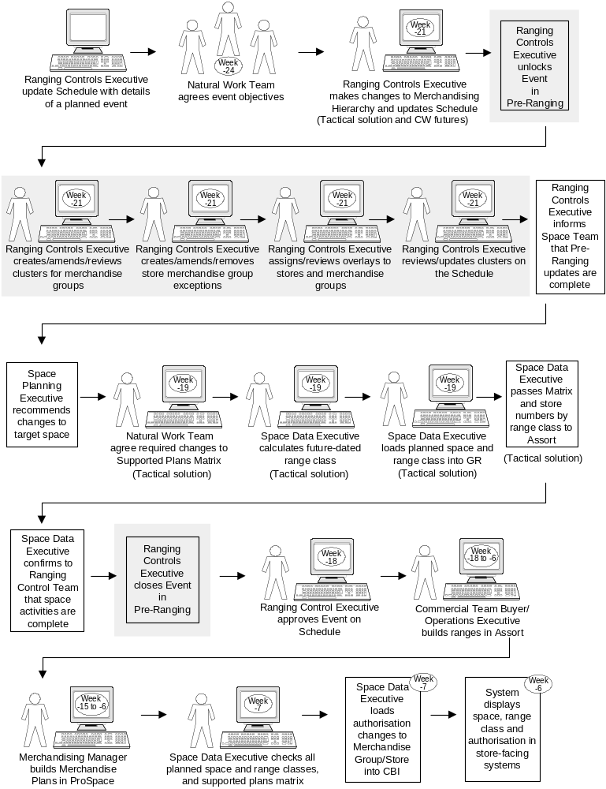

Scheduled Event Process Flow
(Post implementation of Ranging Controls Phase A)

1. Introduce a new merchandising group
If a new merchandising group is to be introduced, the event is logged in the Event Schedule and a new Merchandising Group created in the Merchandising Group Maintenance.

2. Change clusters in an existing merchandising group
Changing clusters in an existing merchandising group could be caused by either:
- A change of the associated attributes for a merchandising group e.g. stop or start using the attribute “format” for ranging the merchandising group.
- Re-clustering based on existing attributes, e.g. split out extras and superstores.

3. Add/delete overlay associated with a merchandising group
If the Commercial Operations Executive requests a change to a merchandising group’s overlay, for example, to remove the overlay for “ethnic area” from the merchandising group “Ready Meals”, the event is entered into the Schedule.

4. Add/amend/delete overlay associated with a store
An overlay associated with an individual store may be changed if, for example, a new store had been built in a popular sea-side resort. The new store would require a sea-side overlay to allow it to stock products that cater for tourists; the store that previously served the tourists would require its sea-side overlay to be removed.

5. Introduce a new Value for an Attribute
If UKTG decide to introduce a new value for an attribute, the event would need to be added to the Event Schedule by the Ranging Controls Team. Adding a new attribute value must be added to the Schedule because a new range will be required in Assort.

A new Value for an Attribute may occur for example, if a new store format is introduced that is significantly different to the other formats, and there are sufficient numbers of the stores that a new Attribute Value must be defined. For example, HomePlus stores that carry only non-food ranges.

Note that adding a new Value to an Attribute in Pre-Ranging has no consequence until the Value is assigned to stores, and clusters are created that contain those stores.

6. Add/Amend a merchandising group exception for a Store
A merchandising group exception would be required if, for example, a store has the Format Value of an Extra, but its physical space is more like that of a Superstore. The exception would be created for some Merchandising Groups to allow the Superstore range to be supplied.

When an exception is added/amended to a merchandising group for a store, the event may be added to the Event Schedule because the store would require different range and merchandising plans.

7. Create a new Overlay
If a new overlay is required, the reason for the overlay, e.g. a store change would be noted in the Event Schedule, however, the overlay itself can be cretaed at any time.

Note that creating a new overlay has no consequence until it is assigned to store clusters and Merchandising Groups.

Processes triggered by UKBE
Processes triggered by UKBE are not event driven i.e. they are not added to the Event Schedule. This means that the Pre-Ranging process is simpler.

Processes triggered by UKBE are:
- Create a new store
- Extend an existing store
- Re-fit an existing store

This section describes each of these processes in detail.

8. Create a new store
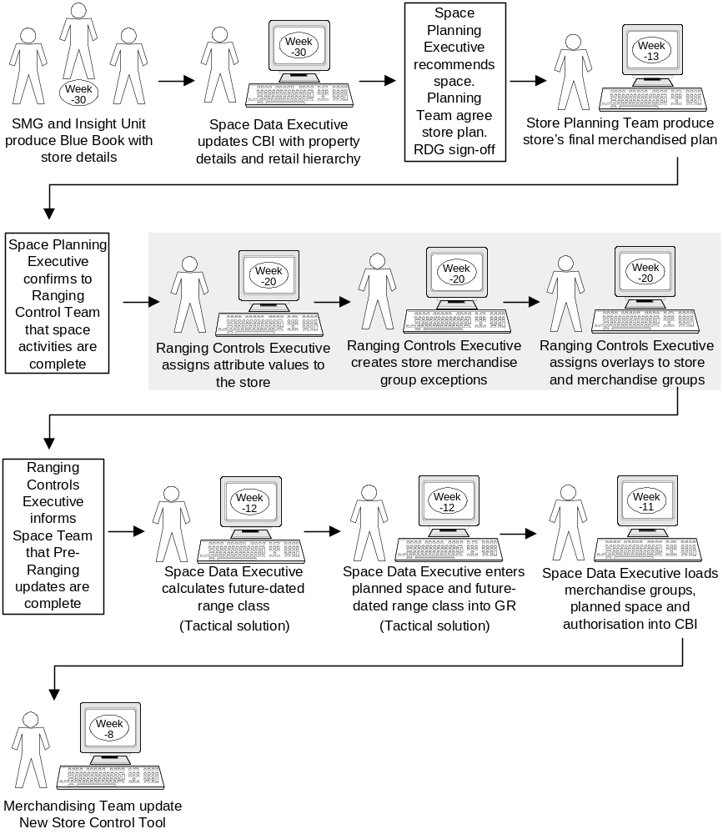

UKBE Create a New Store

Blue Book
Document produced by the InSight team for each new store and major extension. It contains all the store details, such as site location, local demographics, local competition, forecast turnover per department, proposed opening date, store size, etc. The data it contains is used in Pre-Ranging to define the Attribute Values and identify any overlays.

New Store Control Tool
Table used by the Merchandising Team to control when a store starts to receive generic and store-specific merchandising plans.

9. Extend an existing store
The required changes in Pre-Ranging may include the store’s overlays, exceptions or occasionally the store format.

For example, a store may have had an exception to restrict the size of range it could carry for a specific Merchandising Group. However, after an extension has been built, the store will have sufficient space to carry the full range of goods. Therefore the store’s exception in Pre-Ranging will need to be removed.

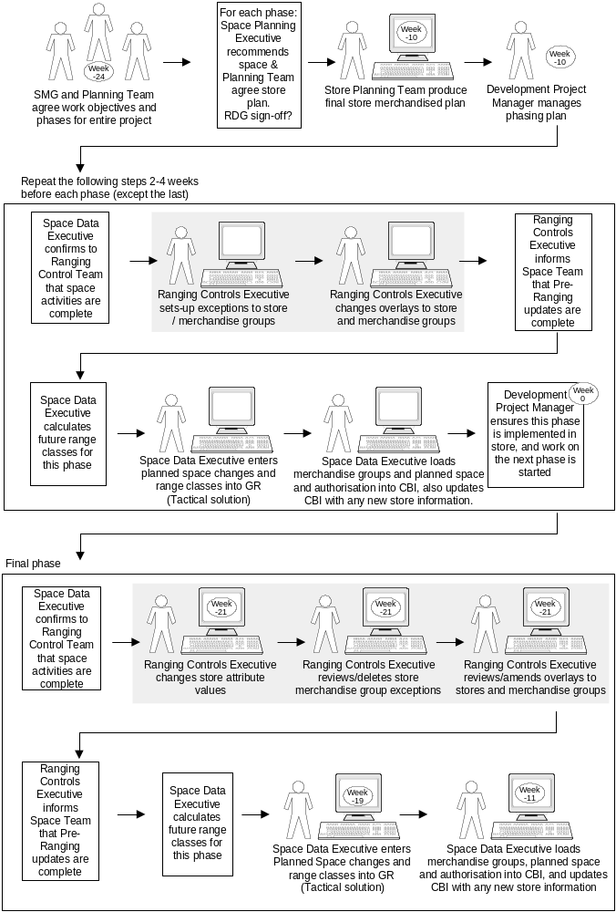
UKBE Store Extension Process

10. Re-fit an existing store
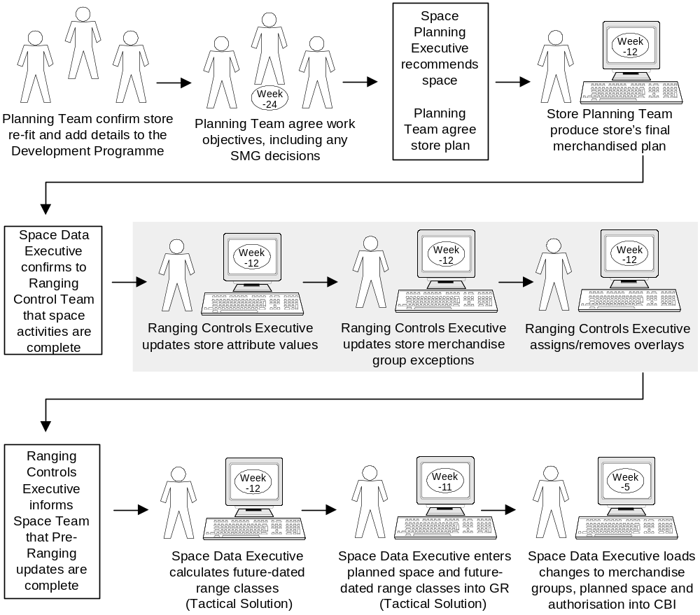

UKBE Store Re-fit Process

Processes triggered by exceptional circumstances
Processes triggered by an exceptional event occur infrequently and include:

- Stores Marketing Group (SMG) introduce a new attribute value (e.g. a new store format such as HomePlus)
- Stores Marketing Management Group (SMG) delete an attribute value (e.g. a store format such as Superstore)
- UK Trading request clustering by a new attribute type (add an attribute type) e.g. “Busyness”
- UK Trading request the deletion of an attribute type e.g. store format

All these exceptional circumstance processes:
- Require the re-assigning of Attribute Type or Value in Pre-Ranging.
- Will eventually be incorporated into an event logged in the Event Schedule, to launch the changes

This section describes each of these processes is detail.

11. UKTG introduce a new attribute value
If UKTG introduce a new store format e.g. a Tesco HomePlus, a new Attribute Value for the existing Attribute Type “format” must be created in Pre-Ranging, then selected stores assigned to that value.

Creating a new attribute value, assigning stores to it and defining new cluster names can be done outside a Scheduled Event because it has no impact on the stores. However, any activity that directly affects the merchandising groups going into the store, e.g. assigning clusters to merchandising groups, must be done as part of a Scheduled Event.

Issues with this process:
- If the additional process steps to create the new clusters and assign them to all merchandising groups have not been completed, stores that have moved to the new attribute value will have no region code assigned to them on the effective date of the change and they
- may also be un-linked from their merchandising groups
- Need to review every merchandising group. This would require every Merchandising Group to be on the schedule.
- No reporting available to check which merchandising groups are using the value to be deleted, and therefore which merchandising groups need to be changed.
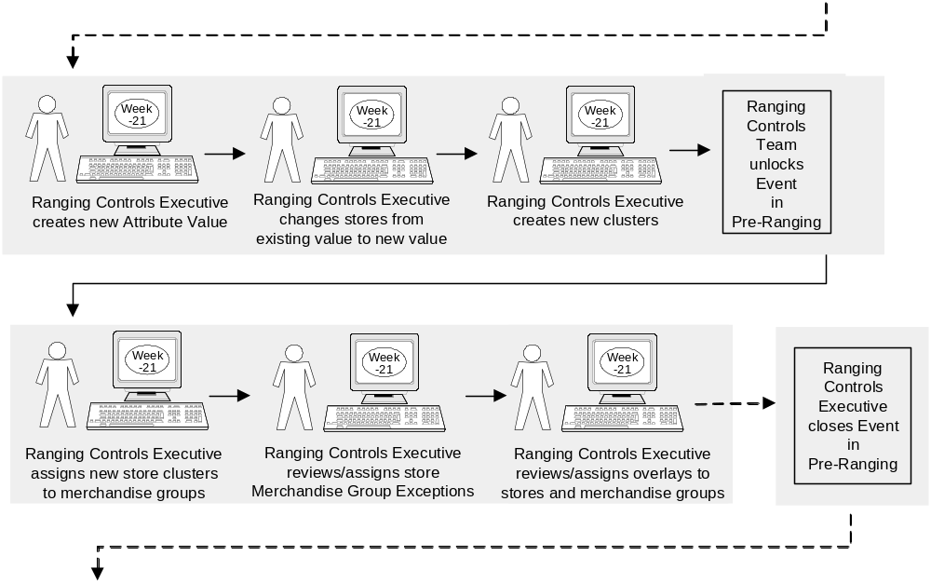
- For every new cluster a huge amount of work is required in creating a new supported plans matrix, merchandising plans, and ranges.

Creating a new attribute value
e.g. introducing a new store format

12. SMG delete an attribute value
Store formats are defined in Pre-Ranging as Attribute Values. If SMG decided to no longer support a store format, the affected stores must be re-defined as a different type, then the Attribute Value deleted from Pre-Ranging. This process applies to deleting any attribute type.

Issues with this process:
- The system does not tidy up the clusters automatically so any clusters that have used that attribute value have to be manually deleted.
- All clusters must be checked to ensure they do not use the deleted attribute value name.
- The system does not notify of any linked merchandising exceptions.
- Affected stores could change range class for every merchandising group.

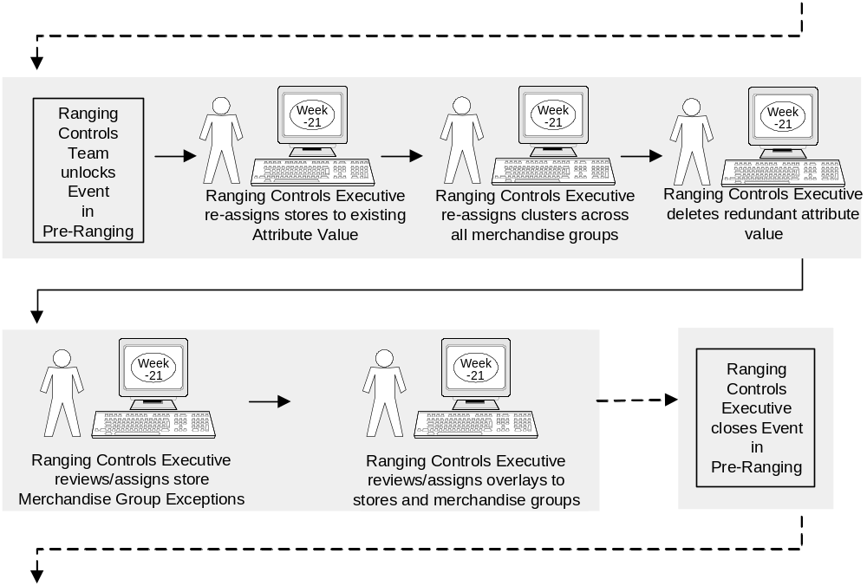
Deleting an Attribute Value
e.g. deleting a store format

13. UK Trading request clustering by a new attribute type
The currently defined attribute types used for clustering stores are Format, Country and Affluence. If UK Trading requested clustering by a new attribute type, e.g. Busyness, a new attribute type and values would be created in Pre-Ranging.

Pre-Ranging requires all stores to be assigned a value for each attribute type, therefore creating a new attribute type will require every store to be updated and potentially change the name of all clusters, even if the attribute type is not used in it.

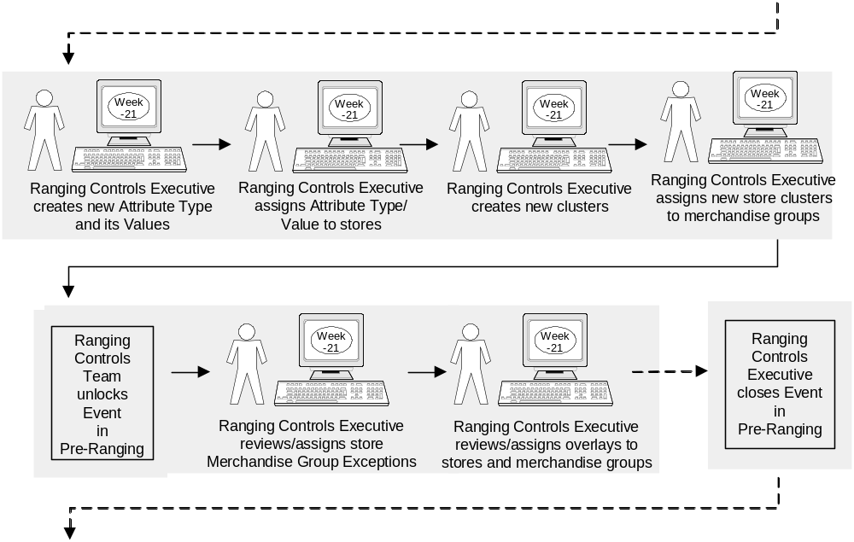
Creating a new Attribute Type and Values
e.g. to cluster by a new attribute type

14. UK Trading request the deletion of an attribute type
If UK Trading decide that stores are no longer to be clustered using a particular criteria, e.g. Format, Country or Affluence, the Attribute Type (and its values) should be deleted from Pre-Ranging.

Deleting an Attribute Type is currently not possible in Pre-Ranging because of the design of the system. The current design that restricts deletion states:
- All stores must be assigned to one value for each attribute type at all times.
- No attribute can be deleted whilst it has stores linked to it

Therefore, the only way currently that an attribute can be deleted is through Change Control, i.e. requesting a change to the design of the current system.

Current Process Issues

Interface design
- Screens are not user-friendly or intuitive. For example, naming conventions are inconsistent, screen refreshes after every data entry, field labels are not always indicative of the function of the field, the grouping of related functionality is not always clear and/or logical
- Menu options do not follow the day-to-day business process. Menus follow the initial set-up of the system, i.e. when data is loaded into the Pre-Ranging system for the first time. Menus should be grouped according to the daily business processes.
- Interface design does not meet Ranging Controls standards. See the Standards document and the BSD for Ranging Controls (Flightdeck) for further detail.

Locking and unlocking events
- Locking and unlocking events does not belong as part of the Pre-Ranging business process. This functionality will be covered for all Ranging Control applications through the Schedule which will be released in Ranging Controls Phase A. Therefore, although locking/closing an event is still part of Pre-Ranging processes, this functionality will be redundant.

Process control
- No level of control for deleting or creating Attribute Types and Attribute Values. Because of their association with clusters, deleting or creating attributes requires extensive work in Pre-Ranging. If performed incorrectly, it could disassociate stores from merchandising groups.
- Changes are effected immediately in the Pre-Ranging screens, with no reference to the previous state and no opportunity to re-confirm changes.
- Not possible to delete attribute types.

Clusters

- Cannot select directly from pre-defined clusters. To assign a cluster to a merchandising group, a list of pre-defined cluster names cannot be displayed. Therefore the cluster has to be re-defined, meaning that the cluster is defined twice.

Data integrity
- No visibility of future-dated changes.
- If something is changed before a future-dated change, the future-dated entry is deleted. However, the system does notify that the entry is going to be deleted.
- Pre-Ranging is for authorised store/merchandising groups only. The authorisation process step comes after Pre-Ranging in the business process, around week –6. The Space Team must maintain a manual spreadsheet of authorisations that will change; these are manually entered into the space matrix at week –19.
- Region code has to be assigned manually. The system does not offer a selection from the available letters but displays all possible codes whether already used or not..(Therefore the user has to repeatedly input a letter until the system finally accepts it as the next available one).

Current System and Architecture

Current System
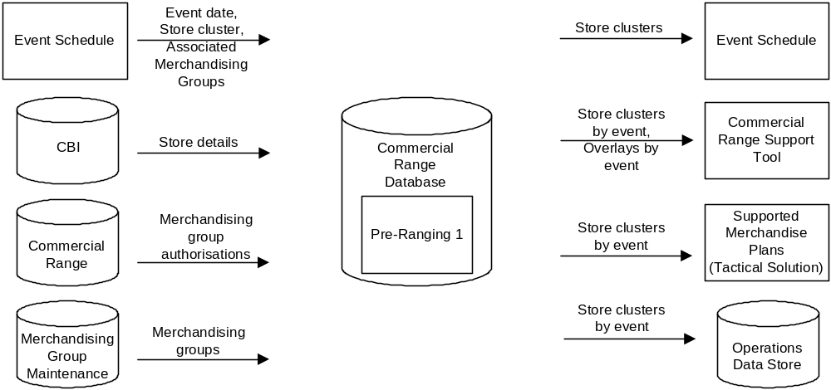
Pre-Ranging Systems

Current architecture
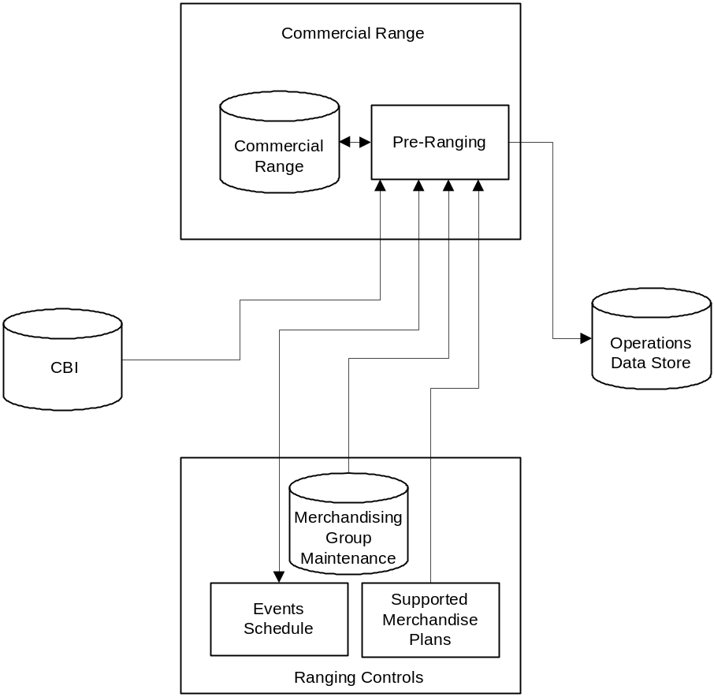
Pre-Ranging System Architecture

“TO BE” BUSINESS PROCESS

Introduction
The To-Be business processes for Store Clustering are very similar to the As-Is Pre-Ranging processes. This is because:
- Several of the issues with the original process for clustering stores were addressed as part of the Pre-Ranging 1 project.
- A further set of issues around store clustering processes have been addressed as part of the Ranging Controls Phase A release (delivery of Phase A is the As-Is state for Store Clustering).
- The majority of outstanding issues in the As-Is processes impact the design of the Pre-Ranging system and not the process steps.

Note: In the To-Be process there will still be two different To-Be processes for the following:
- All countries/formats that still use CBI after Pre-Ranging 1 is live, are out of scope for this project
- All countries/formats that are in scope for this project will use Store Clustering

Because the ROI and Express do not follow the same business process as other store formats and countries, the ROI and Express stores will continue to use CBI for region codes. When these stores change to use the same business processes, they will use the To-Be processes defined in this section. Alternatively, there may be a programme-wide project that looks at the processes required for them to use the Ranging Controls systems.

Process Overview
The difference between the As-Is and To-Be processes are concerned with 4 process steps, 2 of which (Unlocking/Closing Events) occur only in processes triggered by scheduled events.

The differences are caused by other components and functionality being launched as part of Ranging Controls Phase A, and Ranging Controls Phase B. These projects are defined fully in the following documents:
- BSD Merchandising Schedule v1.3
- BPD Planned Space and Authorisation v1.2
- BSD Planned Space and Authorisation v1.0

Schedule – Phase A
Following the launch of Ranging Controls Phase A, the Schedule will manage the Unlocking and Closing of Events (as a manual process). However, the functionality to manage it will not be removed from Pre-Ranging and is therefore in the Pre-Ranging As-Is process.

The functionality will be removed in Store Clustering therefore the steps for Event Unlocking/Closing will not be in the To-Be processes. (Unlocking and Closing Events occur only in processes triggered by Scheduled Events.)

As-Is Process Step | To-Be Process Step
Unlock Event in Pre-Ranging | <<Step no longer required>>  Strategic solution using Ranging Controls Schedule
Close Event in Pre-Ranging | <<Step no longer required>>  Strategic solution using Ranging Controls Schedule

Planned Space and Authorisation – Phase B
Planned Space and Authorisation to be delivered in Phase B includes enhanced functionality for the maintenance of Target Space at store merchandising group level, including a facility to make target space available to other systems. This removes the tactical solution from the following Space Team step:
- Space Data Executive loads planned and range class space into GR

And, since authorisation will now be managed by the system, removes the need for the following Space Team step (for areas in scope):
- Space Data Executive loads authorisation changes to Merchandising Group/Store into CBI

As-Is Process Step | To-Be Process Step
Space Data Executive loads planned space and range class into GR  (Tactical Solution) | Space Data Executive loads target space and range class into Ranging Controls  (Strategic solution using Ranging Controls Target Space)
Space Data Executive loads authorisation changes to Merchandising Group/Store into CBI | <<Step no longer required>>  (Strategic solution using Ranging Controls Target Space)

Note:
All other tactical solutions shown in the To-Be processes will be addressed as part the of Ranging Controls Phase C delivery.

To-Be Processes

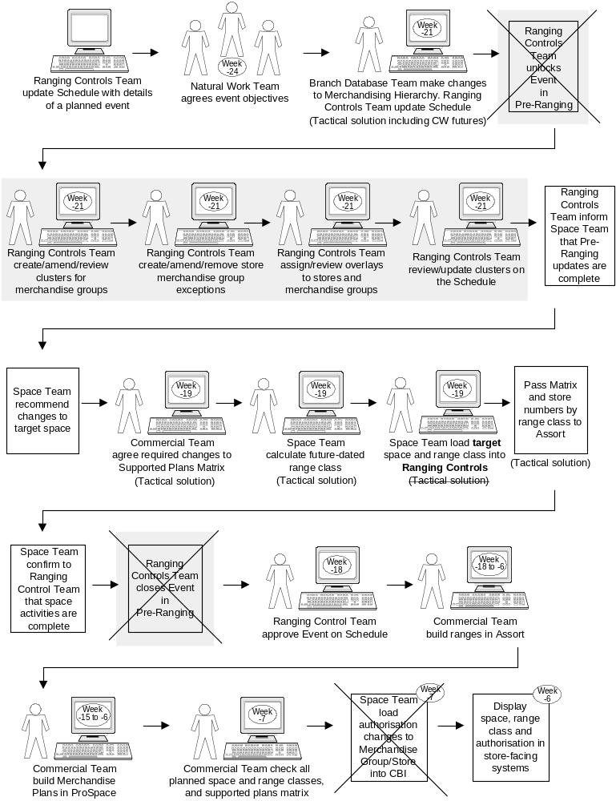
Processes triggered by a Scheduled Event

To-Be Scheduled Event Process Flow
(Same as the As-Is process, except for marked deletions)

Processes triggered by UKBE
- Create a new store
- Extend an existing store
- Re-fit an existing store

These To-Be processes are exactly the same as the As-Is processes, except for two steps:

As-Is Process Step | To-Be Process Step
Space Data Executive loads planned space and range class into GR  (Tactical Solution) | Space Data Executive loads target space and range class into Ranging Controls  (Strategic solution using Ranging Controls)
Space Data Executive loads authorisation changes to Merchandising Group/Store into CBI | <<Step no longer required>>  (Strategic solution using Ranging Controls)

Processes triggered by exceptional circumstances
- Create a new attribute value
- Delete an attribute value
- Create a new attribute type
- Delete an attribute type

The first 3 processes are the same as the As-Is processes, except for the following 2 steps for unlocking/closing events:

As-Is Process Step | To-Be Process Step
Unlock Event in Pre-Ranging | <<Step no longer required>>  Strategic solution using Ranging Controls Schedule
Close Event in Pre-Ranging | <<Step no longer required>>  Strategic solution using Ranging Controls Schedule

Delete an attribute type will use the following new process.

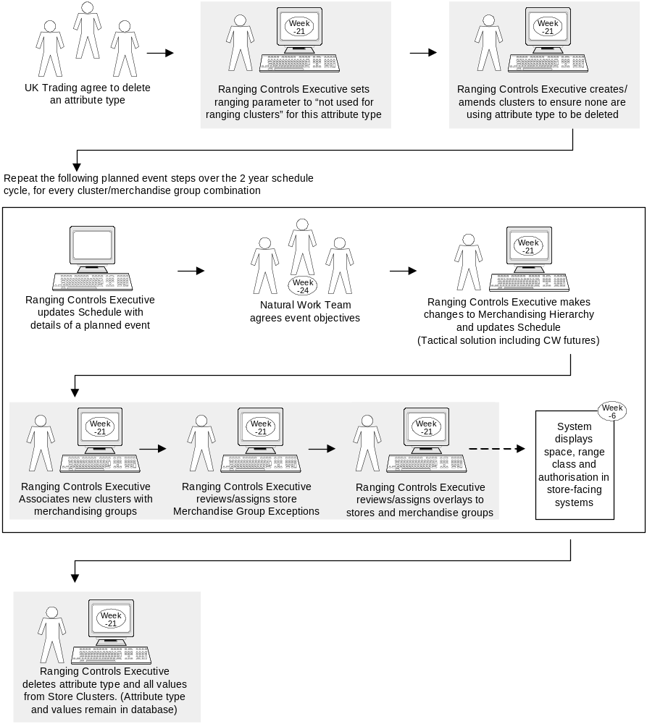
To-be process: Delete Attribute Type

To-Be System Architecture
There are no changes required to the system architecture for Store Clustering.

REQUIREMENTS
This section lists all of the requirements that need to be met by the Business Process and System Design to support the introduction of Store Clustering.

Business Process Requirements

Follows Ranging Controls end-to-end business process
- Store Clustering must follow the Ranging Control end-to-end business processes
- Screen flows should guide the user through the end-to-end business process
- Functionality should be offered without concern for the authorisation status of merchandising groups, because store merchandising group authorisation is defined later in the end-to-end process
- Store Clustering must be the only point of reference for attributes/clusters/overlays for all merchandising groups (including food non-food, seasonal, promotional, supplementary), all UK and Northern Ireland stores, and all formats in scope.
- Ability to delete attribute types so that they are not visible to users, but are retained in the underlying database until all merchandising groups have been disassociated
- Ability to control which attribute types may be used to cluster stores for ranging purposes

Integrated into all parts of the business
- Store Clustering must be integrated into the process for work generated by all parts of the business e.g. UKBE work, scheduled events, store-led changes, special projects and ad-hoc requests

Enhanced functionality to manage the process
- Data defined in Store Clustering must be readily available for the Ranging Controls Team to manage their daily business processes
- Appropriate levels of control must be in place to ensure the integrity of the business process. This should include appropriate user-access levels that control the availability of functions, validation, and operational reporting.
- Where appropriate, the system must prompt users to confirm changes before they are saved, and notify users to confirm changes have been saved successfully
- An appropriate amount of history should be retained in the system
- Deleting an attribute type or value, overlay, or cluster must be controlled, with thorough system checks and appropriate access levels.
- Exceptions for future dates to be viewed by store or merchandising group over time.
- Exceptions to be defined at department level for UKBE changes.

Data availability and reporting
- Operational data in the system should be easily visible for business users. This should be enabled through intuitive and easy-to-use reporting screens
- On-screen and hard copy reports should be available if required
- A full set of data must be available to the data warehouse for ad-hoc reporting
- Ability to control whether attribute information is available for retail reporting

System Requirements

Maintain the functionality and integration of Pre-Ranging1
- Store Clustering must retain the core functionality of Pre-Ranging1, including the ability to make multiple future-dated changes, manage attributes, link attributes to stores/merchandising groups, define clusters
- Where required, links to down-stream systems must be retained, e.g. CRST, Space Range and Merchandising Schedule, Range Operations Data Store (ODS)
- The requirements of CRST must continue to be met

Interface must be intuitive and easy to use
- Focus of menus must be structured around business maintenance processes, and not the initial set-up process as in the current system.
- Store Clustering must be easy to use and maintain, and its functionality intuitive
- The functionality must be easy to understand
- The “look and feel” must meet the standards of all Ranging Controls applications, as defined in the following documents:
- BSD for Ranging Controls
- Screen Design Standards
- Redundant functionality must be removed

- Consistent terminology and labels must be used throughout that are appropriate to the business users
- To improve usability, a facility to add/store/display descriptions for each overlay should be added. This will ensure overlays are not duplicated and are created only once. Overlay names must also be unique.

Sufficient flexibility to change data at any time
- User access levels must be defined for operations that have a critical impact on down-stream systems. Access levels to include Support, Super-user, User, and Enquiry
- Rules and access levels for making changes after critical points in the process must be clearly defined
- Functionality to be added that allows future-dated changes in Store Clustering to be amended (or deleted) at any point in the critical path

System integration with Ranging Controls applications
- Store Clustering must be fully integrated into the Ranging Controls application delivered as part of Ranging Controls Phase A and Ranging Controls Phase B
- Store Clustering must be accessed through the Ranging Controls front-end
- The “look and feel” must meet the standards of all Ranging Controls applications, as defined in the following documents:
- BSD for Ranging Controls (Flightdeck)
- Screen Design Standards
- Store Clustering must integrate fully with Events in the Schedule
- It is assumed that informing Assort that that an Event is ready to be cascaded through to the other systems (unlocking an event) will be controlled by the Schedule after Ranging Controls Phase A. Therefore the Locking and Unlocking functionality in Store Clustering will be redundant and must be removed.
- A clear distinction must be made between tasks that can be done outside the Schedule and those that are controlled as part of a Scheduled Event. This distinction will be reflected in the user access levels required to perform the tasks.
- The Region code must be assigned automatically.

Improved functionality for creating clusters
- The naming convention for clusters must be simple for the business to manage
- All clusters must use a consistent naming convention as defined by business rules

Other Requirements

Process and design moving towards required IT Strategy
- Store Clustering processes must move towards the required IT Strategy, including removing the dependency on CBI for ranging data
- The design must be inline with strategic technical design
- The functionality must continue to meet the requirements of the Space Range and Merchandising Programme for Assort, Ranges In Progress (RIP) and Pro-Space.

Adequate level of documentation and training
- All documentation, training and training material provided as part of Pre-Ranging1 must be updated to reflect the changes for Store Clustering
- Adequate documentation, training and training material must be provided to support Store Clustering.

SOLUTION ISSUES & RISKS

Risks
Risk | Consequences | Probability | Impact | Next Steps
If change control on Pre-Ranging is not completed, As-Is for Store Clustering will be unstable/inaccurate. | Required system changes may be unclear which will lead to delays to the technical design. | L | H | Review change control progress at monthly project board.
Limited time to add stakeholder feedback between Process Document sign-off and issue of System Design | Extensive change to the To-Be process and requirements, or lack of sign-off cannot be accommodated and will result in milestone slippage | M | H | Two stage sign-off process (review of document and discussion of feedback) to maximise time available for amending documentation
Aggressive timelines for delivery; no contingency in the project plan if required | Increased probability of process or system design error, or milestone slippage | H | H | Weekly review of milestone plan and project progress with team.  Monthly review with stakeholders

Issues
Risk | Consequences | Probability | Impact | Next Steps
SLAs/OLAs not agreed | Deliverables will not meet business non-functional requirements | H | M

APPENDICES

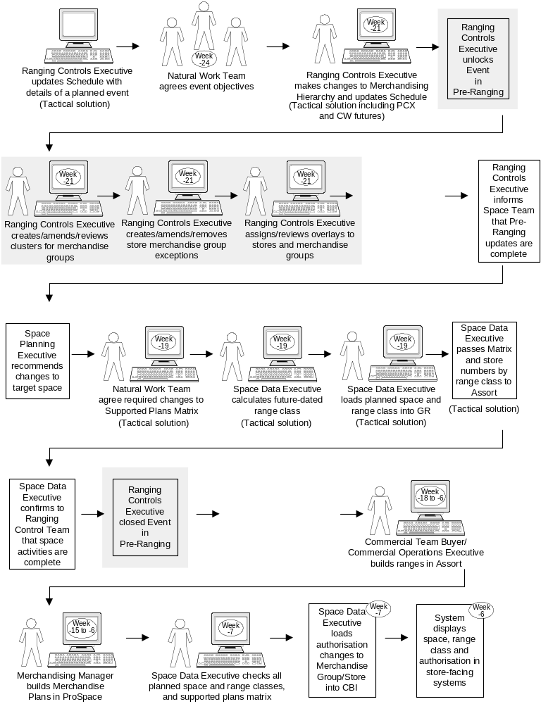
Appendix A – Scheduled Event flow, pre-Phase A

Scheduled Event Process Flow
(Prior to implementation of Ranging Controls Phase A)

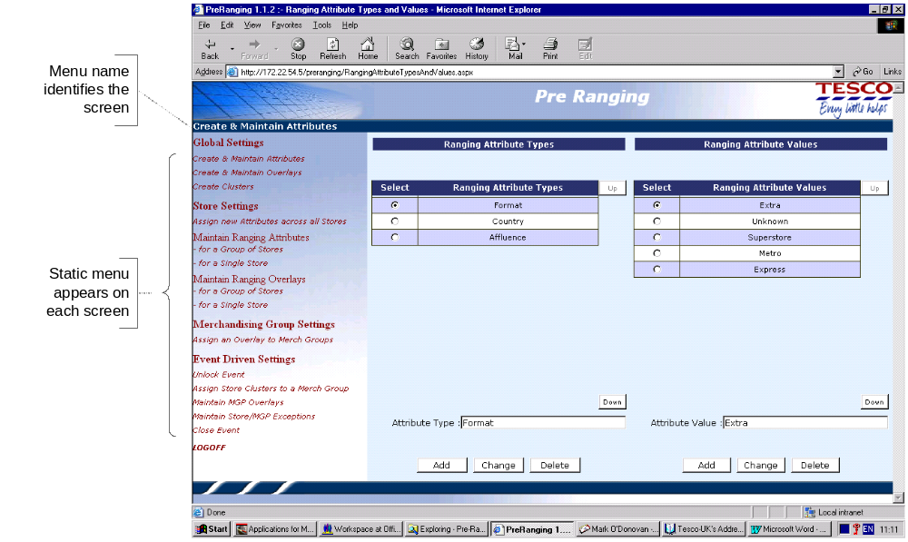
Appendix B – Application Overview (As-Is)

Pre-Ranging Navigation

The Pre-Ranging application software has a user interface as shown in the Pre-Ranging Navigation screen shot. Menu choices are shown on the left of each screen and are divided into 4 functional areas reflected in the menu structure:

- Define global settings
- Define store settings
- Merchandising Groups Settings
- Define events-driven settings

Menus can be selected in any order, depending on the task to be performed.

Access Modes
There are currently three types of access mode:
- Update Normal access – set up and maintain merchandising groups and store ranging attributes, overlays, and clusters.
- Update Override access – as Update Normal access, but with added permission to update the Pre-Ranging application within the lead-time of an Event.
- Enquiry access – read only access used by the Commercial, Merchandising and Space Team. (Note: this mode is currently unusable as there are no enquiries to see. Users have to go part way to making an update to be able to get meaningful results from an enquiry.)

User access is set-up through the .NET application.

Change Status (Locking/Unlocking)
To prevent other applications from accessing data whilst changes are still being made, Pre-Ranging data is controlled by an event status. There are 3 event status values:

Status | Description
Pending | This status occurs automatically when the event first appears in Pre-Ranging. In this state, no system activity can take place i.e. no changes in Pre-Ranging can be made, and no information can be fed into CRST and made available to other systems.
Pre-Ranging | To get into this state from Pending, the event must be Unlocked in Pre-Ranging. In the Pre-Ranging state, clusters and other information can be defined in Pre-Ranging. However, no information can be fed into CRST and made available to other systems.
Ready | To get into this state from the Pre-Ranging state, the event must be Closed in Pre-Ranging. In the Ready state, no further changes can be made in Pre-Ranging by users with Update Normal access.  Information in the Ready state is fed into CRST automatically the night after the Ready status is set. After which, the Event status changes to CRST.

Event lead time

During an Event’s lead-time, changes to Pre-Ranging are permitted only by users with Update Override access, and if the information from Pre-Ranging has not been fed into CRST (i.e. the Event status is not CRST or In Progress or Authorised).

